**DAILY ONLINE ACTIVITIES SUMMARY**

|  |  |  |  |  |  |  |  |  |
| --- | --- | --- | --- | --- | --- | --- | --- | --- |
| **Date:** | 08-06-2020 | | | | | **Name:** | Anvitha H M | |
| **Sem & Sec** | 4th ‘A’ | | | | | **USN:** | 4AL18CS010 | |
| **Online Test Summary** | | | | | | | | |
| **Subject** | | Complex analysis, probability and statistical methods. | | | | | | |
| **Max. Marks** | | 30 | | **Score** | | | 12 | |
| **Certification Course Summary** | | | | | | | | |
| **Course** | Introduction to digital marketing. | | | | | | | |
| **Certificate Provider** | | | Great learning academy | | **Duration** | | | 5.5 hours |
| **Coding Challenges** | | | | | | | | |
| **Problem Statement:**  Program in java to check whether the given matrix is magic square or not. | | | | | | | | |
| **Status:** Executed | | | | | | | | |
| **Uploaded the report in Github** | | | | | YES | | | |
| **If yes Repository name** | | | | | <https://github.com/anvithahm/LOCKdown-coding> | | | |
| **Uploaded the report in slack** | | | | | Yes | | | |

**Online test:**

M-4 test was scheduled from 9:30am to 10:10am. The portion for the IA was module 2 there were 15 questions and the time assigned was 40minutes the questions were MCQ type. I scored 12/30.

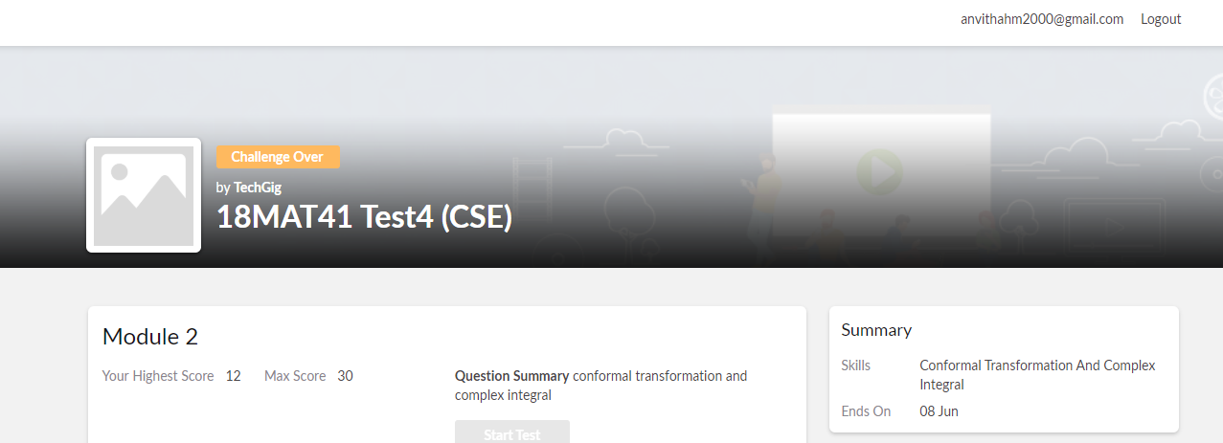

**Certification course:**

Introduction to digital marketing

The course introduction to the Facebook marketing, purpose of using it as marketing channel and its interface, types of audience we come across.



Online coding challenge

The programing statements of the day is “program in java to check whether the given matrix is magic square or not”.

Solution: Executed and uploaded in Github repository.

Link: <https://github.com/alvas-education-foundation/Anvitha-H-M>

